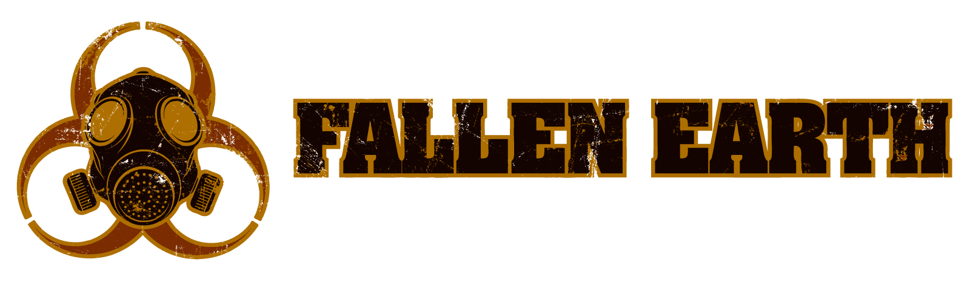

FALLEN EARTH HISTORICAL INFORMATION

It was an age of nanotechnology and cloning filled with rumors of superhuman soldiers and artificial intelligences. Despite technological and martial advances, the enemy was undetected. Shiva struck silently, beginning as a fatal flu epidemic in southern Asia. Rampant questions and a panicked public tried to determine the source. Was it a biological anomaly? A government project gone awry?

Continental devastation sparked questions of biological warfare as tensions mounted. One nation believed the virus to be a targeted attack from a neighbor nation, retaliating with nuclear warfare. As the exchange between countries escalated, the death toll rose into the hundreds of thousands. Further ravaging the population, the nuclear blasts flung irradiated dust laced with the Shiva virus into the atmosphere, where it mutated into a more potent form.

Chaos overwhelmed the world. Major cities in Europe and North America, including those in the United States, were crippled. The virus mutated as it spread, wiping out more than 90 percent of civilization.

In its last incarnation, Shiva 7 displayed similar but non-lethal symptoms. This dominant version of the virus affected nearly all survivors, with subsequent generations realizing hidden effects of the strain. The virus caused mutations—some benign, some malignant, and some inexplicable. A few even had the capability to manipulate the world around them. The fundamental genetic composition of humanity was forever altered.

Hoover Dam, the last bastion of civilization in the Grand Canyon Province, fell to the Children of the Apocalypse and their allies after decades of conflict. The Enforcers and Techs, once servants of the reviled ruler of Hoover Dam, Alec Masters, are searching for a new place in the world. Factions struggle to assert their power in Fallen Earth. Will their efforts result in a peaceful regime, or a barren wasteland propagated by hate?

FALLEN EARTH, LLC is the creator of the self-titled MMO Fallen Earth. Fallen Earth is a massively multiplayer online game mixing first-person shooter style action with traditional role-playing game design. The game features more than 1,000 square kilometers of landscape to explore and conquer, 70 towns, six distinct factions, a classless advancement system and a unique crafting feature. The missions you choose determine who you are—will you ally with a faction or rally against it?

Fallen Earth Facebook Page
Twitter: FallenEarth

©2009 FALLEN EARTH, LLC, all rights reserved.

